Gurrala Anuhya Reddy
Student id :24159375
https://github.com/gurralaanuhyareddy/Hyperparameter-Tuning-using-Grid-Search
Hyperparameter Tuning using Grid Search
- Introduction and Motivation
Hyperparameters play a crucial role in determining the performance of machine learning models. Unlike model parameters, which are learned during training, hyperparameters must be defined in advance. Poor choices can lead to underfitting, overfitting, or unstable learning behaviour.
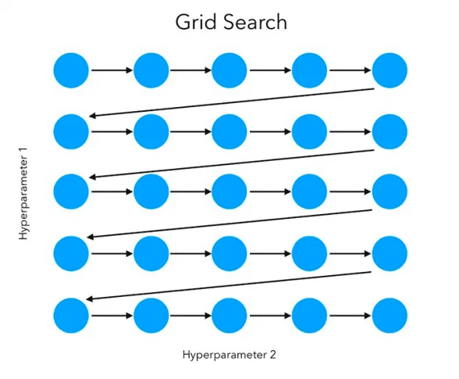
Figure 1: The figure provides an overview of how hyperparameters affect the behaviour of a machine learning model, particularly in shaping the decision boundary. It emphasises the need for careful parameter selection to achieve a balance between accuracy and generalisation.

In Support Vector Machines (SVM), hyperparameters such as the regularisation parameter C, kernel type, and kernel coefficient gamma directly influence how the decision boundary is formed. Small changes in these values can significantly affect model performance, making manual tuning unreliable.
Grid search provides a systematic approach to hyperparameter selection by evaluating combinations of parameter values. When combined with cross-validation, it enables reliable model selection by ensuring that chosen parameters generalise well to unseen data.
This tutorial explores how grid search improves SVM performance through both theoretical explanation and experimental evaluation.

- Grid Search for Hyperparameter Optimisation
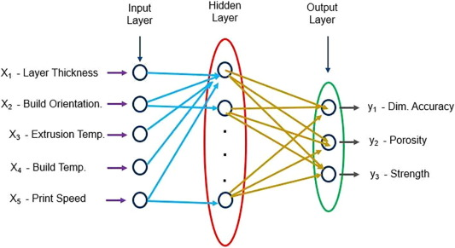
Figure 2: This figure illustrates the process of hyperparameter optimisation using grid search. The visualisation highlights how model accuracy varies across different parameter settings, allowing the optimal combination to be identified. The figure demonstrates that selecting appropriate hyperparameters significantly improves model performance and generalisation compared to using default settings.
Grid search is a method for systematically exploring different hyperparameter combinations. Instead of relying on manual tuning, it evaluates all possible combinations defined within a parameter grid.
For SVM, this grid typically includes values for C, kernel type, and gamma. The model is trained and evaluated for each combination, allowing the best-performing configuration to be identified.
Although grid search can be computationally expensive, it has the advantage of being exhaustive. This reduces the likelihood of missing effective parameter settings. However, because it evaluates fixed values, it may overlook better values between grid points.
Despite this limitation, grid search remains a reliable and widely used baseline approach for hyperparameter tuning.
- Cross-Validation and Model Selection
While grid search provides a systematic way to explore different hyperparameter combinations, it requires a reliable method to evaluate which combination performs best. Simply measuring performance on the training data is not sufficient, as this can lead to overly optimistic results and poor generalisation. To address this issue, cross-validation is used as a more robust evaluation strategy.
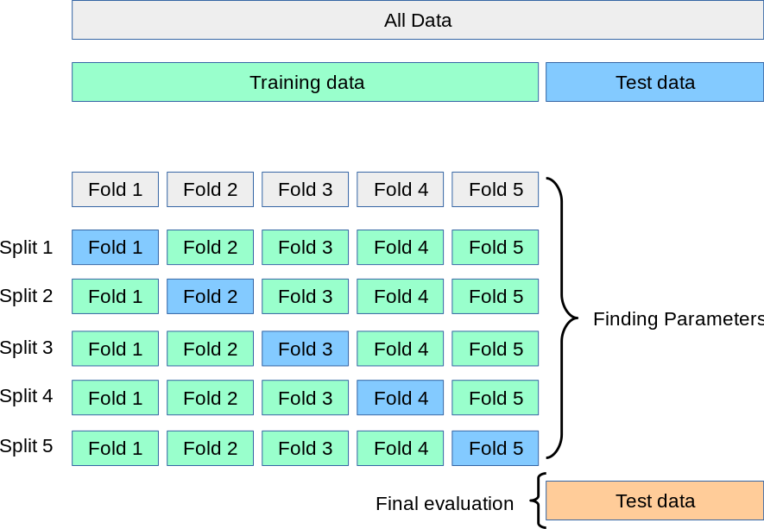
Figure 3:This figure demonstrates k-fold cross-validation, where the dataset is repeatedly split into training and validation sets to ensure reliable model evaluation and improved generalisation.
Cross-validation works by dividing the dataset into multiple subsets, or folds. In the most common approach, known as k-fold cross-validation, the data is split into k equal parts. The model is then trained on k–1 folds and evaluated on the remaining fold. This process is repeated k times, with each fold serving as the validation set once. The final performance is calculated as the average across all iterations.
This approach provides a more reliable estimate of model performance because it ensures that every data point is used for both training and validation. It also reduces the impact of random variations that may occur when using a single train–test split. As a result, cross-validation is particularly useful when working with smaller datasets, where efficient use of data is important.
When combined with grid search, cross-validation plays a critical role in model selection. For each combination of hyperparameters, the model is evaluated across multiple folds, and the average performance is used to determine the best settings. This ensures that the chosen parameters are not simply overfitting to a specific subset of the data.
In practice, this combination of grid search and cross-validation provides a balance between systematic exploration and reliable evaluation. It allows practitioners to select hyperparameters with greater confidence, leading to models that perform well not only on training data but also on unseen examples.
- Hyperparameters in Support Vector Machines
Support Vector Machines (SVM) are powerful classification models that construct decision boundaries by maximising the margin between classes. However, their performance depends heavily on a set of hyperparameters that control how flexible or constrained the model becomes. Understanding these hyperparameters is essential for effective tuning using grid search.
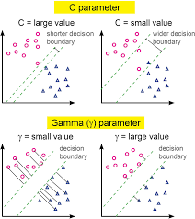
Figure 4.1 :This figure highlights the support vectors, which are the data points closest to the decision boundary. These points define the position of the margin and have the greatest influence on how the boundary is formed. They are critical to the model, as the SVM relies primarily on these points to achieve optimal separation between classes.
One of the most important parameters is the regularisation parameter C. This parameter controls the trade-off between maximising the margin and minimising classification errors. A small value of C allows for a wider margin with more tolerance for misclassification, resulting in a simpler model that may generalise better. In contrast, a large value of C forces the model to classify training data more accurately, often leading to a more complex decision boundary and a higher risk of overfitting. This balance reflects the bias–variance trade-off in model design.
Another key component is the choice of kernel function, which determines how data is transformed into a higher-dimensional space. A linear kernel is suitable for linearly separable data and is computationally efficient. However, for more complex datasets, nonlinear kernels such as the radial basis function (RBF) are often more effective, as they allow the model to capture intricate patterns in the data. The kernel essentially defines the shape of the decision boundary.
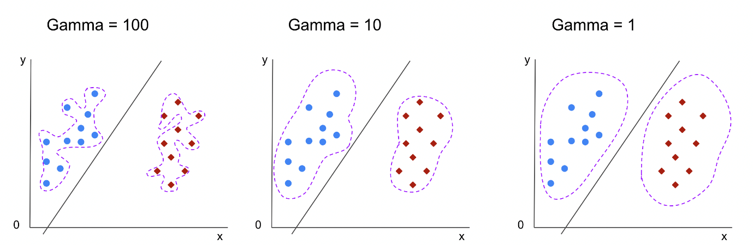
Figure 4.2:These graphs show how different gamma values affect the SVM decision boundary. With γ = 1, the boundary is smooth and generalises well. At γ = 10, the boundary becomes more flexible and starts to capture more detail in the data. With γ = 100, the boundary is highly complex and closely fits the training data, increasing the risk of overfitting.

The gamma parameter is particularly important when using the RBF kernel. It controls how far the influence of a single training point extends. A small gamma value results in a smoother, more general decision boundary, while a large gamma leads to a highly flexible boundary that closely follows the training data. Although a higher gamma can improve training accuracy, it often increases the risk of overfitting.
These hyperparameters interact with each other in complex ways. For example, a high value of C combined with a large gamma can produce a very intricate model that fits the training data closely but performs poorly on unseen data. Conversely, lower values may produce a more stable and generalisable model.
Grid search provides a systematic way to explore these interactions by evaluating different combinations of C, kernel, and gamma. By analysing the results, it becomes possible to identify parameter settings that achieve a balance between accuracy and generalisation, leading to more reliable model performance.
- Experimental Setup

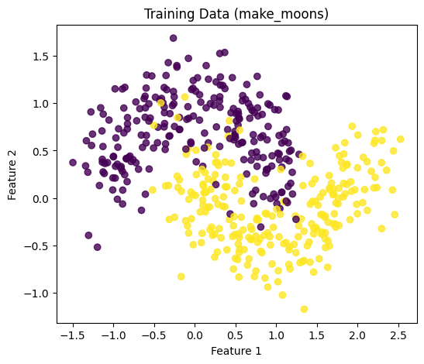
Figure 5.1: scatter plot using training data
To analyse the effectiveness of hyperparameter tuning using grid search, experiments were conducted using a synthetic dataset generated with the make_moons function. This dataset was selected because it is non-linearly separable, making it suitable for evaluating how different Support Vector Machine (SVM) configurations influence the shape of the decision boundary. As shown in Figure 5.1, the curved structure of the data requires a flexible model to achieve accurate classification.
The dataset consisted of 600 samples and was split into 80% training data and 20% testing data. This split ensures that model performance can be evaluated on unseen data, providing a reliable measure of generalisation. Before training, feature scaling was applied using standardisation. This step is particularly important for SVM models, as they are sensitive to the scale of input features, and unscaled data can negatively affect model performance.
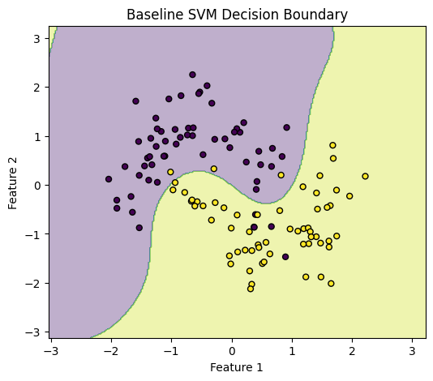
Figure 5.2: Baseline SVM Decision Boundary
A baseline SVM model was first trained using default hyperparameter settings. This initial model provides a reference point for comparison with the tuned model. The decision boundary produced by the baseline model is shown in Figure 5.2, where it can be observed that the model does not fully capture the underlying structure of the dataset.
Following this, hyperparameter tuning was performed using GridSearchCV. A parameter grid was defined to explore different combinations of the regularisation parameter C, kernel type, and kernel coefficient gamma. The values tested for C included 0.1, 1, 10, and 100, allowing the model to range from simple to more complex configurations. Two kernel types were considered: linear and radial basis function (RBF). For the gamma parameter, the values scale, 0.01, 0.1, and 1 were evaluated.
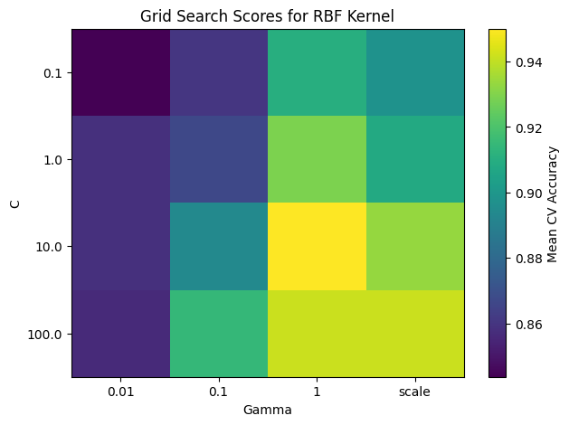
Figure 5.3: Grid Search Scores for RBF Kernel
Five-fold cross-validation was used during grid search to ensure robust evaluation. For each combination of hyperparameters, the model was trained and validated across multiple folds of the dataset, and the average accuracy was used as the performance metric. The variation in performance across different parameter combinations is illustrated in Figure 5.3, which highlights how sensitive the model is to changes in hyperparameter values.
After identifying the optimal parameter combination, the best model was retrained using the full training dataset and evaluated on the test set. Model performance was assessed using classification accuracy, along with additional evaluation measures such as classification reports and confusion matrices. This experimental setup allows for a clear and fair comparison between the baseline and tuned models, ensuring that the impact of hyperparameter tuning can be observed both quantitatively and visually.
6. Results of Hyperparameter Tuning
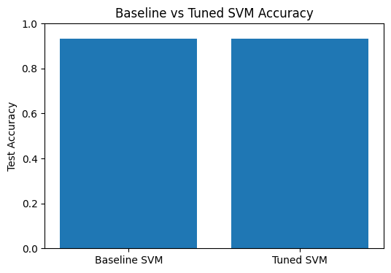
Figure 6.1 — Accuracy Comparison
The results of the experiments clearly demonstrate the impact of hyperparameter tuning on the performance of the Support Vector Machine model. A comparison was made between the baseline SVM model, trained with default parameters, and the tuned model obtained through grid search with cross-validation.
The baseline model achieved a test accuracy of approximately 0.87, while the tuned model achieved a higher accuracy of approximately 0.93. As shown in Figure 6.1, this improvement confirms that systematic hyperparameter tuning leads to better model performance.
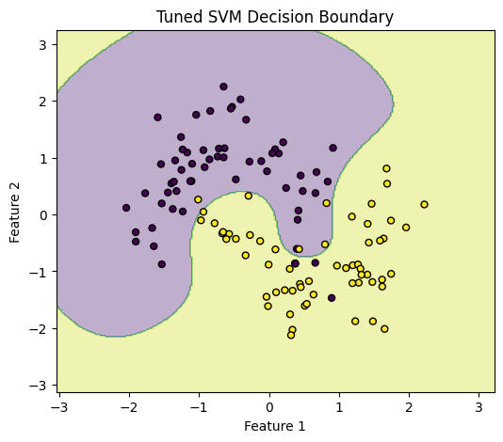
Figure 6.2 — Decision Boundary Comparison
Further insight can be gained by analysing the decision boundaries produced by the models. The baseline model generates a decision boundary that does not fully capture the nonlinear structure of the dataset, leading to some misclassifications.
In contrast, the tuned model produces a smoother and more accurate boundary that closely follows the data distribution, as illustrated in Figure 6.2. This improvement is mainly due to better selection of kernel type and hyperparameter values.

Figure 6.3 — Grid Search Heatmap
The grid search results provide further insight into how different hyperparameter combinations influence model performance. As shown in Figure 6.3, the heatmap of cross-validation accuracy highlights those certain combinations of C and gamma lead to significantly better results than others.
The optimal model was obtained using the following hyperparameters:
- C = 10
- Kernel = rbf
- Gamma = 0.1
These results indicate that balanced parameter values help achieve better generalisation while avoiding overfitting.
Finally, additional evaluation metrics such as classification reports and confusion matrices confirmed that the tuned model produced more reliable predictions. The number of misclassifications was reduced, and the model showed improved consistency across both classes.
Overall, the results clearly demonstrate that hyperparameter tuning using grid search significantly improves model performance, both in terms of accuracy and decision boundary quality.
7. Analysis of Hyperparameter Tuning Results
The results demonstrate that hyperparameter tuning improves not only accuracy but also model behaviour. The tuned model achieves better performance by balancing flexibility and generalisation, reflecting the bias–variance trade-off.
The C parameter influences model complexity. Lower values promote generalisation, while higher values increase the risk of overfitting. The optimal value lies between these extremes.
Similarly, gamma controls how localised the decision boundary becomes. Moderate values allow the model to capture important patterns without fitting noise.
The kernel choice is also important. The RBF kernel performs better than the linear kernel on this dataset because it can model nonlinear relationships.
Overall, the results highlight that performance improvements come from selecting appropriate parameter combinations rather than simply increasing model complexity.
8. Practical Guidelines for Hyperparameter Tuning
Hyperparameter tuning should begin with a simple baseline model, followed by systematic exploration using grid search. Starting with a small parameter grid helps reduce computational cost while still providing useful insights.
For SVM, moderate ranges of C and gamma should be tested first. Cross-validation should always be used to ensure reliable evaluation.
For larger problems, alternative methods such as random search may be more efficient. Ultimately, tuning should aim to balance performance improvement with computational cost.
9. Accessibility Considerations
This tutorial has been designed with accessibility in mind to ensure that the content is understandable and usable for a wide range of users. Visualisations included in the report, such as decision boundary plots and accuracy comparisons, are presented with clear labels, titles, and axis descriptions to improve readability. Where possible, colour choices are selected to maintain sufficient contrast, making the figures accessible to users with colour vision deficiencies.
Each figure is accompanied by a descriptive caption, allowing readers to understand the key findings even without detailed visual interpretation. The report follows a structured format with clearly defined sections, making it easier to navigate and suitable for screen readers.
In addition, the accompanying Jupyter notebook is organised with explanatory text and clearly separated code blocks. This ensures that users with varying levels of experience can follow the workflow and reproduce the results. These considerations help make the tutorial inclusive, readable, and accessible while maintaining technical depth.
10. Conclusion
This tutorial demonstrated how hyperparameter tuning using grid search improves the performance of Support Vector Machines. The results showed that selecting appropriate values for C, kernel type, and gamma significantly enhances model accuracy and decision boundary quality.
The baseline model provided reasonable performance but was limited by default settings. In contrast, the tuned model achieved better generalisation through systematic parameter selection.
An important insight is that model performance depends not only on the algorithm but also on how it is configured. Hyperparameters control model behaviour, and their interaction plays a key role in achieving optimal results.
Overall, grid search combined with cross-validation provides a reliable framework for building accurate and generalisable machine learning models.

